Comprehensive Instrument Database: MusicHub will offer an extensive database containing information, history, and tutorials for less famous and dying musical instruments, allowing users to explore and learn about these instruments.

How playing an instrument benefits your brain - Anita Collins
40,000 years of music explained in 8 minutes | Michael Spitzer

Prime instruments:-

- Harpejji

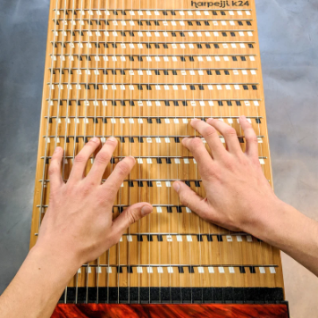

Interactive Infographics:

In 2007, musician, experimental instrument maker and Marcodi Musical Products founder Tim Meeks, created the Harpejji, a really cool stringed, amplified instrument that employs the principles of guitar, piano, harp and percussion. The player taps the strings with one finger rather than forming chords to strum and can use the wooden frame to provide a back beat.

The Harpejji is a member of a small family of stringed musical instruments known as tapping instruments. Tapping instruments are descendants of the electric guitar but are optimized for a style of playing that involves tapping on the strings to produce a note. One of the primary benefits of this style of playing is that it only requires one finger to make each note, unlike strumming which requires at least one finger on each hand to make a note. By freeing up more fingers, the player has the freedom to play arrangements that are physically too difficult to play with the more traditional playing techniques. Unlike all other commercially available tapping instruments, the harpejji has a keyboard-inspired playing interface that many will find easier to learn, more comfortable to play and more interesting to explore.

Audio clips and samples:

If I Rise - A R. Rahman & Dido (127 Hours OST)
A.R.Rahman playing the Harpejji
Ennile Maha Oliyo - A.R Rahman, Rayhanah, Issrath Quadhri - Coke Studio @ MTV Season 3
Jagao Mere Des Ko - A.R Rahman, Suchi, Blaaze - Coke Studio @ MTV Season 3
Exploring Harpejji Soundscapes
<Create immersive, interactive storytelling experiences that take users on a journey through the history and evolution of the harpejji>
User generated content:
Indian similar instrument:
- Santoor:
1. Ancient Roots:The Santoor has a lineage dating back over 3,000 years, making it one of India's oldest known musical instruments. It can be traced to the ancient Indian epic, the Rigveda.
2. Kashmiri Heritage: The Santoor is closely associated with the region of Kashmir in northern India. It holds a special place in Kashmiri culture and has been a key instrument in the traditional Sufi and folk music of the region.
3. Instrument of the Sufis: The Santoor has been traditionally used in Sufi music, a mystical and spiritual form of Islamic music. It has played a role in conveying the devotion and transcendence of Sufi poets and musicians.
4. Raga Music:In Indian classical music, the Santoor is featured in both Hindustani (North Indian) and Carnatic (South Indian) classical traditions. It has become an integral part of the performance of ragas (melodic modes) and tala (rhythmic cycles).
5. Contemporary Fusion: While rooted in tradition, the Santoor has also found its place in contemporary and fusion music. Many Indian and international musicians have incorporated it into their compositions, bridging cultural boundaries.
7. Global Recognition: Renowned Santoor player Pandit Shivkumar Sharma is credited with popularizing the instrument globally. His pioneering work in Indian classical music has earned him acclaim worldwide.
https://en.santurasangita.com/santour
https://www.instagram.com/santoormangesh/
Bolly songs: Santoor used in Bollywood songs! | The Santoor is a trapezoid-shaped hammered dulcimer musical instrument, indigenous to the Kashmir valley. This instrument is generally made of walnut... | By iqwat | Facebook
Add shopping links

- Tumbi
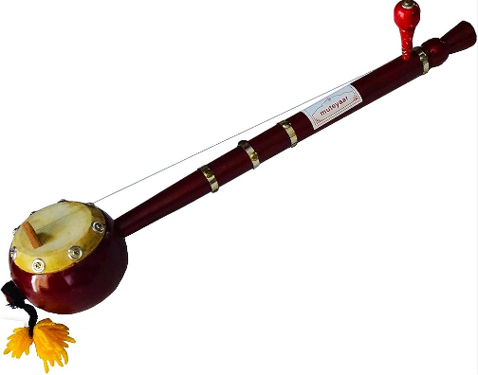

History:

The Tumbi is a traditional folk instrument that originates from the Punjab region of North India and Pakistan. It has a long history deeply rooted in Punjabi and North Indian folk music traditions. The Tumbi has been an integral part of Punjabi culture for centuries, playing a vital role in storytelling through music.

Design:

- Structure: The Tumbi is a stringed instrument, typically small and portable. It consists of a single, slender wooden neck with a resonator at one end. The resonator is often a dried gourd or a wooden box.

- Stringing: Traditionally, the Tumbi features a single metal string that runs along the length of the neck. The string is usually plucked with the player's index finger and, occasionally, the thumb.

- Frets:The Tumbi typically has no frets, which allows for smooth sliding of the player's fingers along the neck to create the microtonal slides and glissandos characteristic of its sound.

Cultural Significance:

1. Punjabi Folk Music: The Tumbi is inseparable from Punjabi folk music, especially the Bhangra genre. It is known for its lively, energetic, and celebratory sound, making it a favorite in Punjabi festivals and weddings.

2. Bhangra Dance:The Tumbi is a vital accompaniment to the Bhangra dance, a vibrant and high-energy dance form from Punjab. The lively, rhythmic sound of the Tumbi sets the pace for dancers and adds to the overall excitement of Bhangra performances.

3. Storytelling: In traditional Punjabi music, the Tumbi is often used to accompany singing and storytelling. Musicians use it to narrate tales of love, valor, and everyday life in the region.

4. Versatility: Despite its simple design, the Tumbi is remarkably versatile. Skilled players can produce a wide range of tones, pitches, and rhythms by adjusting finger pressure and plucking techniques.

5. Iconic Sound:The twangy, melodic, and sometimes soulful sound of the Tumbi is instantly recognizable. It captures the essence of Punjabi culture and resonates with audiences worldwide.

6. Modern Fusion: While deeply rooted in tradition, the Tumbi has found its way into modern music genres, including contemporary Punjabi and Bollywood music. It has become a symbol of cultural pride and identity.

7. Instrument of Celebration: The Tumbi is associated with joy, celebration, and community gatherings. It is often used to uplift spirits and create an atmosphere of festivity.

8. Musical Education: The Tumbi is taught and learned by aspiring musicians, passing on the rich heritage of Punjabi music to future generations.

9. Global Appeal:Punjabi music, with the Tumbi at its heart, has gained international popularity. The instrument's catchy tunes and beats have transcended borders and contributed to the global spread of Punjabi culture.

https://www.india-instruments.com/various-string-instrument-details/tumbi.html

Sound sample: https://www.youtube.com/watch?v=xo8kVVP_aks
BEE2 Tumbi x Brown Munde

- Alghoza

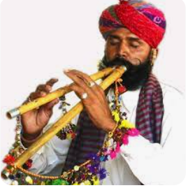
The Alghoza, also known as the Algoza or Alghozay, is a traditional musical instrument primarily associated with Punjabi folk music, especially in the region of Punjab, which spans across India and Pakistan. Here's some information about the Alghoza:

History:
The Alghoza has a long history, dating back centuries. It is a wind instrument made of two flutes, typically made from reed or bamboo. Each flute has seven or eight holes, which are used to produce musical notes. It is believed to have originated in the rural areas of Punjab, where it was used for folk and devotional music.

Design:
The Alghoza consists of two parallel flutes of different sizes, usually bound together. One flute is for melody, and the other is for drone accompaniment. The smaller flute plays the melody while the larger one produces a continuous drone sound. Players use their mouth and fingers to create different tones by covering or uncovering the holes on the flutes.

Cultural Significance:

1. Folk Music Tradition: The Alghoza is an integral part of the rich folk music tradition in Punjab, a region known for its vibrant and diverse musical heritage. It is often associated with Bhangra and other traditional dance forms, adding a lively and festive element to celebrations.

2. Harbinger of Joy: In Punjabi culture, the Alghoza is often seen as a symbol of joy and celebration. It is commonly played at weddings, festivals, and other joyous occasions. Its upbeat and energetic tunes encourage people to dance and celebrate.

3. Sufi and Spiritual Connection: Beyond its role in secular festivities, the Alghoza also holds spiritual significance. It has been used in Sufi music and Qawwali performances to create a trance-like atmosphere during devotional gatherings. The instrument's soulful tunes are believed to connect listeners with the divine.

4. Versatile Instrument: The Alghoza is a versatile instrument that can be played by a single musician, unlike many other traditional instruments that require an ensemble. This versatility makes it accessible to individual performers and small groups.

5. Regional Variations: Different regions of Punjab have their variations of the Alghoza. These variations include differences in the number of holes, size, and the way the instrument is played. Each regional variation adds a unique flavor to the music.

Fun Facts:

1. Double-Flute Design: The Alghoza's design features two flutes bound together, each with a distinct role. One flute produces the melody, while the other provides a continuous drone. The harmonious interplay between these flutes creates the unique and melodious sound of the Alghoza.

2. Bamboo or Reed Construction: Traditionally, Alghozas were crafted from natural materials such as bamboo or reed. Skilled artisans handcraft these instruments, carving intricate designs on them.

3. Rapid Playing Techniques: Alghoza players often use rapid and skillful techniques to create a lively and dynamic musical performance. This can include quick finger movements and breath control to produce a wide range of notes and rhythms.

4. Global Influence: While the Alghoza is deeply rooted in Punjabi culture, its captivating sound has gained international recognition. Musicians around the world have incorporated it into various music genres, infusing a taste of Punjabi folk music into their compositions.

5. Symbol of Identity: For Punjabi communities, the Alghoza can be a symbol of identity and pride. It reflects their cultural roots and serves as a reminder of their heritage, even when they are living far from their homeland.

Songs Where It Has Been Used:
The Alghoza is featured in numerous traditional Punjabi and Sindhi folk songs. It's commonly used in celebratory and dance music.

The Alghoza continues to be an important part of the cultural heritage of the Punjab region, and it has also gained recognition and appreciation in other parts of the world due to its distinctive and melodious sound.

What does an alghoza sound like?
Kamal Khan | Tu Bol Pahve Na Bol | Ninja | Alghoza | Live | Studio Round 12 | VOP Chhota Champ 4
https://www.dawn.com/news/1430327

- Chimta
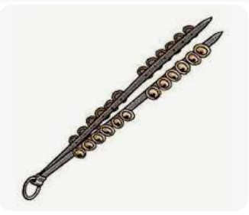

History:

The Chimta has a long and rich history that is deeply intertwined with Punjabi culture and music. It has been a part of Punjabi folk music for generations, and its origins can be traced back many centuries. The exact timeline of its development is not well-documented, but it has been a vital element of the region's musical traditions for a very long time.

Design:

1. Structure: The Chimta consists of two metal rods or tongs that are connected at one end, forming a hinged structure resembling a pair of scissors. The tongs are typically made of iron or steel for durability and resonance.

2. Metal Jingles: Small metal jingles, often in the form of round or oval-shaped discs, are affixed to the inside surfaces of the tongs. These jingles create the characteristic metallic sound when the Chimta is played.

3. Hinged Mechanism: The hinged design of the Chimta allows the player to open and close the tongs rhythmically. When the tongs are struck together or shaken, the metal jingles collide, producing a rhythmic and percussive sound.

4. Decorative Elements: Chimtas are often adorned with decorative elements, such as colorful threads, beads, or even small bells. These decorations add to the instrument's visual appeal and cultural significance.

Cultural Significance:

1. Punjabi Folk Music: The Chimta is an integral part of Punjabi folk music, particularly in the Bhangra and Giddha traditions. It provides the essential rhythmic accompaniment that drives these energetic and lively dance forms.

2. Celebrations and Festivals: The Chimta is prominently featured in Punjabi celebrations, including weddings, festivals, and cultural events. Its upbeat and festive sound encourages people to dance and celebrate with enthusiasm.

3. Dance Performances: In traditional Punjabi dance performances, Chimta players often take center stage alongside dancers. Their skilled playing enhances the overall performance, making it visually and aurally captivating.

Fun Facts:

1. Regional Variations: While the basic design of the Chimta remains consistent, there can be regional variations in its construction and ornamentation, reflecting local craftsmanship and aesthetics.

2. Collaboration with Other Instruments: Chimta players often collaborate with other musicians, including Dhol players (drummers) and Alghoza players (double-flute musicians), creating a vibrant ensemble of sounds in Punjabi music.

3. Global Influence: The infectious rhythms of the Chimta have transcended cultural boundaries and gained popularity in various parts of the world. It has been incorporated into fusion music, adding a Punjabi touch to global musical genres.

4. Skilled Artistry: Playing the Chimta requires skill and precision. Experienced players can produce a wide range of rhythms, from rapid beats to melodic patterns, showcasing their artistry.

5. Cultural Identity: The Chimta is not just a musical instrument but also a symbol of Punjabi cultural identity. It embodies the region's joyous and celebratory spirit and is cherished by Punjabi communities worldwide.

The Chimta's history, design, cultural significance, and ability to infuse celebrations with rhythm and energy make it an iconic instrument in Punjabi culture and music. It continues to be a source of joy and connection among Punjabi communities and music enthusiasts worldwide.

Chimta lesson with Arif Lohar
Singing on chimta
Kamal Heer: Chimta (Full Video) || Kamal Heer || Jai Bala Music || Latest New Mata De Bhajan 2018
Arif Lohar

- Duff

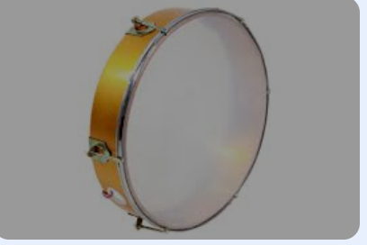

History:

The Duff, also spelled as "Daf" or "Davul," is a traditional percussion instrument with a history dating back thousands of years. Its origins can be traced to various regions of the Middle East, Central Asia, and North Africa. The Duff has played a significant role in both secular and sacred music traditions in these regions, with variations and adaptations found in diverse cultures.

Design:

1. Frame: The Duff typically consists of a circular frame made of wood, metal, or other materials. The frame is often hollow and open on one side, allowing for resonance.

2. Head: The circular frame is covered with a stretched membrane or head, traditionally made from animal skin (such as goat or fish skin) but sometimes synthetic materials are used in modern versions.

3. Jingles: One of the distinctive features of the Duff is the presence of small metal or metal-ring jingles attached to the inside of the frame. These jingles create a rattling or jingling sound when the instrument is played.

4. Decorations: Duffs are often elaborately decorated with ornate designs, patterns, and sometimes even calligraphy. These decorations can vary widely based on regional and cultural traditions.

Cultural Significance:

1. Religious and Ritual Use: In many Middle Eastern and North African cultures, the Duff holds religious significance and is used in Sufi and Islamic rituals, particularly during dhikr (spiritual remembrance) ceremonies. It is associated with trance-like states and spiritual ecstasy.

2. Folk and Popular Music: The Duff is a versatile instrument used in various forms of folk and popular music across the Middle East, North Africa, and Central Asia. It provides rhythm and adds depth to traditional songs and dances.

3. Dance Accompaniment: In many cultural dances, such as belly dancing, the Duff is an essential accompaniment. Its rhythmic beats guide dancers and add a dynamic element to the performance.

4. Collaboration: Duff players often collaborate with other musicians, including vocalists and instrumentalists, creating a cohesive ensemble that combines melody, rhythm, and percussion.

Fun Facts:

1. Universal Appeal: The Duff's simple yet resonant design has led to its widespread use in various musical traditions around the world. It has adapted and found its place in genres ranging from classical and folk to contemporary and fusion music.

2. Hands-On Playing: Duff players typically use their hands to strike or tap the instrument, creating a range of percussive sounds. The instrument's responsiveness to touch allows for dynamic and expressive playing.

3. Diverse Regional Variations: Different regions have their own variations of the Duff, each with unique characteristics in terms of size, materials used, and playing techniques. For example, the Turkish Daf and the Persian Daf have distinct styles.

4. Cultural Symbolism: In some cultures, the Duff is seen as a symbol of unity and spirituality. Its circular shape is associated with the cyclical nature of life and the universe.

5. Modern Applications: Beyond traditional contexts, the Duff has found its way into contemporary music genres, including world music, fusion, and even rock. Musicians appreciate its earthy and rhythmic qualities.

The Duff's history, design, cultural significance, and adaptability have made it a cherished instrument in numerous musical traditions. Whether used in spiritual rituals, folk celebrations, or modern music, it continues to resonate with both musicians and audiences worldwide.

Duff Sound | Duff Loop | Duffli Sound | JO Sound
Learn to play Iranian Daf - with Naghmeh Farahmand
Sanjay Karandikar teaching to play Duff (Frame Drum) at
www.swartaalsadhana.com

- Sarod
- Rabaab
- Nagphani
- Ghatam
- Idakka
- Morchang
- Jal Tarang (in delhi)
- Ravan hattha
- Khartaal

Resources: https://sci-hub.se/https://www.jstor.org/stable/41919828
https://www.rhythmitica.com/blog/history-of-daff-the-middle-east-frame-drums

Tumbi, Alghoza, Chimta, Duff (will have to look), Ghatam, Morchang, Jal tarang, Ravan Hattha and Khartaal.

https://www.youtube.com/watch?v=Ee0Ez_gV8dY

